TIFF Climate_Report_Figure_3 2011JULY03.tif

Climate Corridor User Guide

**Climate Corridor User Guide**

*Version 0.1 BETA—Updated October 2012*

Darren Kavanagh

Adze Informatics

**Acknowledgements**

Climate Corridor builds upon the Python code developed by Tristan Nuñez as part of his master’s work (Nuñez 2011). I am grateful for Tristan’s help throughout the development of this tool. I am also grateful to my collaborators in the Climate Change Subgroup of the Washington Wildlife Habitat Connectivity Working Group for their feedback and assistance.

**Software Requirements and Licensing**

Climate Corridor runs on the Windows platform only. It requires **GRASS GIS** and **ArcGIS Desktop 10.0 (ArcInfo License)** with the Spatial Analyst extension.

The tool and its source code are provided free of charge under a GNU General Public License. More details can be found on the Linkage Mapper website (<http://code.google.com/p/linkage-mapper/>), where the code is hosted.

**Preferred Citation** (Please obtain permission before citing)

Kavanagh, D.M. 2012. Climate Corridor Connectivity Analysis Software. Adze Informatics, Seattle WA. Available at: <http://code.google.com/p/linkage-mapper/>.

**Table of Contents**

1 Introduction 3

2 Installation 3

3 Using Climate Corridor 4

3.1 Input data requirements 4

3.2 Running from a Python Script 5

3.3 Running the toolbox 7

3.4 Processing Steps 7

4 Climate Corridor tutorial 7

5 Support 8

6 Literature cited 8

# Introduction

Climate Corridor is part of the Linkage Mapper Toolkit, which includes Linkage Mapper (McRae and Kavanagh 2011) and other modules designed to support regional wildlife habitat connectivity analyses. The tool is designed to create linkages between designated core areas that fall along a climatic gradient (e.g. temperature). More details on climate corridor theory and approaches to modeling climate corridors can be found in Nuñez (2011), Washington Wildlife Habitat Connectivity Working Group (WHCWG) (2011) and WHCWG (2012).

For project news and tool updates please visit the project website (<http://code.google.com/p/linkage-mapper/>) and/or join the user group (<http://groups.google.com/group/linkage-mapper>).

# Installation

**1) Download and Install Linkage Mapper**

The ‘Linkage Mapper ArcGIS 10.0’ toolbox can be downloaded from the project website. Open the zip archive and place the *toolbox* directory with all its contents on your computer. Place the *demo* directory in a folder that has no spaces or special characters in its path. To install the toolbox follow the instructions in the Linkage Mapper User Guide, which can be found in the *doc* folder within the *toolbox* directory.

**2) Download and Install GRASS GIS**

GRASS GIS can be downloaded from <http://grass.osgeo.org>. The tool has been tested to run with versions 6.4.2, 6.5 and 7. Please note that versions 6.5 and 7 are development versions and are built daily, so it is possible that the daily build you download may not work with Climate Corridor. I have favored version 7 for analyses that I have conducted. To install GRASS GIS run the downloaded installation file and follow the on-screen instructions.

# Using Climate Corridor

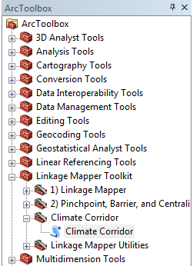To start Climate Corridor select the *Linkage Mapper* toolbox (see Figure 1) in ArcGIS, and click on *Climate Corridor*. The dialog illustrated in Figure 2 should appear. A description of each parameter follows below.

Figure Linkage Mapper Toolkit

## Input data requirements

1. **Model Inputs**
   1. **Project Folder:** This is the windows folder where the final output will be saved. It is also used by the tool to store temporary outputs. This folder should be in a shallow tree and have a short name (something like C:\ANBO), ideally on a local drive for optimum processing speed and reliably. The name of the directory will also be used as a prefix for final Linkage Mapper output files (e.g. ANBO\_LCPs). There should be no spaces or special characters anywhere in the folder path.
   2. 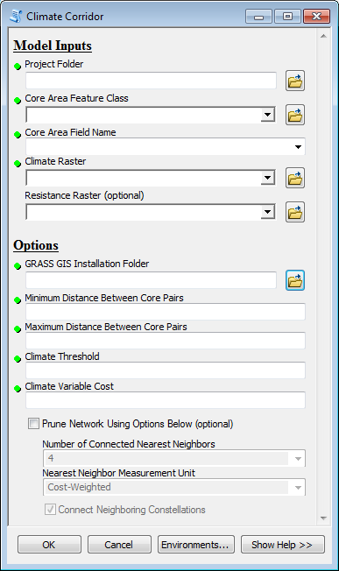**Core Area Feature Class:** Enter the polygon feature class (e.g. shape file) that contains the species core areas (the polygons that will be connected with linkages).

Figure Climate Corridor Input Screen

* 1. **Core Area Field Name:** This drop-down listwill list all attribute fields in the core feature class. The selected field must consist of positive integers < 9999 that uniquely identify unique core areas.
  2. **Climate Raster:** Enter the climate (e.g. temperature) surface here. This can be in any standard raster format that ArcGIS accepts.
  3. **Resistance Raster** (optional)**:** To optionally incorporate other impediments to movement, in addition to climatic variability, a resistance raster can be entered here.

1. **Options**
   1. **GRASS GIS Installation Folder:** For the tool to work correctly you must tell it where GRASS GIS is installed. For GRASS 7 on Windows 7 (64-bit) the default folder is *C:\Program Files (x86)\GRASS GIS 7.0.svn*.
   2. **Minimum Distance Between Core Pairs:** Enter the minimum linkage distance that should separate one core to another. Linkages less than this distance will not be created. The distance unit is that of the input spatial layers.
   3. **Maximum Distance Between Core Pairs:** Enter the maximum linkage distance that should separate one core to another. Linkages greater than this distance will not be created. The distance unit is that of the input spatial layers.
   4. **Climate Threshold:** A positive numeric value, in the same units as the climate raster, that limits core pairs based on climate. Core areas will only be connected if the difference between their lowest mean values is greater than the threshold. The lowest mean value of a core is two standard deviations below the mean of the core.
   5. **Climate Variable Cost:** This is the distance to climate ratio, in cost-distance units per unit change in climate. It is used to calculate the anisotropic cost distance between cores. For example, 50,000 is the appropriate value for a distance-to-temperature ratio of 50 km/1°C, where the map units are in meters.
   6. **Prune Network Using Options Below (optional):** The number of corridors mapped can be optionally limited based on the following parameters. (This section is equivalent to Step 4 in Linkage Mapper).
      1. **Number of Connected Nearest Neighbors:** The number of nearest neighbors to connect each core to. Any links that are not needed to connect each core to its N nearest neighbors are dropped. Allowable range is 1-4.
      2. **Nearest Neighbor Measurement Unit:** Choose whether to measure ‘nearest’ above in Euclidean or cost-weighted distance.
      3. **Connect Neighboring Constellations:** If this option is selected links will be re-added to connect nearest pairs of core area ‘constellations’, i.e. discrete clusters of neighboring core areas, until all constellations are connected.



*Please note that all input spatial layers should be in the same coordinate system. The tool assumes that they are. Furthermore, the spatial extent of the analysis will be the intersection of the input layers.*

Climate Corridor can be run once all the parameters are correctly populated and the OK is pressed. Figure 4 in section 4 illustrates a completed tool screen.

## Running from a Python Script

Climate Corridor can also be invoked programmatically outside of ArcGIS Desktop, although there are many advantages in running it within ArcGIS. The tool is written in Python and can be initiated by calling *cc\_main.py* (in the Linkage Mapper scripts folder) with the appropriate input parameters. An example Python script, *CC Run Script.py*, in the Linkage Mapper demo folder illustrates one way of running the Climate Corridor tool outside of ArcGIS.

## Processing Steps

To generate climate corridors Climate Corridor runs through out a series of computational steps. Some of these steps are logged and reported in the tool’s *Details* window (see Figure 3). These can be helpful in monitoring the tools progress and identifying problems. The main steps are listed below along with a brief description of the action they carrying out:

1. 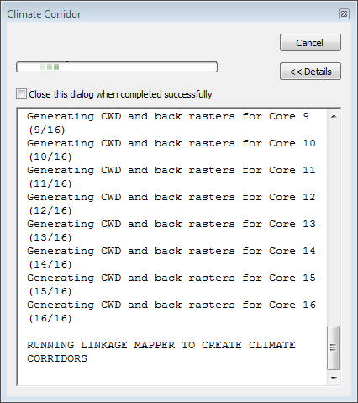**Copy spatial data:** The tool copies the spatial inputs into the clm\_corr folder within the project folder.

Figure Details Screen

1. **Clip to smallest extent:** The spatial inputs are clipped to the extent matching the intersection of all layers.
2. **Calculate zonal statistics:** To get a statistical summary of climate values in each core area the tool calls ArcGIS’s *Zonal Statistics as Table* function.
3. **Create core paring table:** A unique set of core to core pairings are created. For example if you have 3 cores, you end up with 3 core pairings – (Core1-Core2, Core1-Core3, Core2-Core2).
4. **Limit cores based upon climate threshold:** The lowest mean values are calculated and core pairings with a mean difference lower than the threshold are removed.
5. **Limit cores based on Euclidean distances and creating link table for Linkage Mapper:** Core pairs are next filtered by the minimum and maximum distance separating them. A Linkage Mapper link table is created along with the final core pairings.
6. **Run GRASS GIS to create cost-weighted distance rasters:** The anisotropic cost distance between the different core pairings are calculated using GRASS GIS’s r.walk function. As GRASS has its own unique spatial file structure, all inputs have to be imported into a temporary GRASS database.
7. **Run Linkage Mapper to create climate corridors:** When all the cost distance rasters are generated Linkage Mapper is called to create the climate corridors. Linkage Mapper is started at *Step 3*. Final output can be found in the *\lm\_out\output* folder within the project folder**.** More details on Linkage Mapper can be found in its user guide (McRae and Kavanagh 2011).

Most of the file created in steps *a - g* are deleted when they are longer needed. Only two output files are left for the user to review – the zonal statistics table and the final core pairing table. These can be found in the *clm\_cor* folder within the project folder.

# Climate Corridor DEMO

Figure

The Linkage Mapper download comes with sample data that can be used to evaluate and test the Climate Corridor tool. The easiest may to explore the demo data is to open the ArcGIS map document *CC Demo\_Arc10.mxd* in the Linkage Mapper *Demo* folder. To run the demo click on the Climate Tool and enter the *Model Inputs* as illustrated in Figure 4 (substituting the path to the installed demo folder and the GRASS GIS installation folder). While the other options do not have to be followed, those illustrated have been tested to generate output. The final output can be reviewed in a separate map document - *CC Demo Results\_Arc10.mxd*. First the path to each layer in this map will have to be updated to match the project folder. For more information how to interpret Linkage Mapper outputs please see the Linkage Mapper user guide (McRae and Kavanagh 2011).

# Support

Please join the Linkage Mapper User Group for updates. You may also use the issue tracker to report bugs and suggest enhancements. Both of these resources can be found on the Linkage Mapper website, where the code is hosted: <http://code.google.com/p/linkage-mapper/>

# Literature cited

McRae, B.H. and D.M. Kavanagh. 2011. Linkage Mapper Connectivity Analysis Software. The Nature Conservancy, Seattle WA. Available at: <http://code.google.com/p/linkage-mapper/>.

Nuñez, T.A. 2011. Connectivity Planning to Facilitate Species Movements in Response to Climate Change. Available at <http://waconnected.org/climate-change-analysis/>.

Washington Wildlife Habitat Connectivity Working Group (WHCWG). 2011. Washington Connected Landscapes Project: Climate-Gradient Corridors Report. Washington Departments of Fish and Wildlife, and Transportation, Olympia, WA. Available at <http://waconnected.org/climate-change-analysis/>.

WHCWG. 2012. Climate Gradient Corridor Report: Frequently Asked Questions. Departments of Fish and Wildlife, and Transportation, Olympia, WA. Available at <http://waconnected.org/climate-change-analysis/>.